Background
The University of Iowa’s accounting system uses a category of the Fund chart field labeled Agency Funds. Agency Funds are used to account for assets held by the University as custodian or fiscal agent for others. From a financial reporting perspective, the amounts in Agency Funds do not belong to the University.

The list of Agency Funds is shown below.
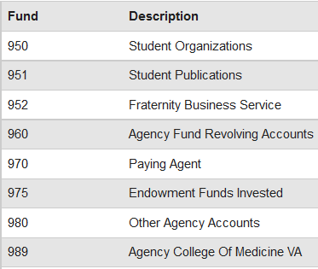

Instances occur where a transfer of amounts between Agency and University Funds must be recorded in the accounting system. This form must be used to document approval of the transaction from the WhoKey Owner(s) of the WhoKeys used and to describe the purpose of the transaction.

Transfers of amounts between Agency and University Funds (Grant Funds 500 or 510 are handled differently – see next paragraph) should be recorded using transfer IACTs (3502-3596 Transfer-In and 7502-7596 Transfer-Out) for proper financial reporting. Departments should not move funds between Agency and University Funds using other IACTs, such as revenue or general expense.

Using a Transfer-in or Out IACTs on Grant Funds 500 or 510 are not normally allowed. WebCV should be used to move expenses. If you are not able to complete the WebCV yourself because the expenses occurred in a prior Fiscal Year or you have a question about whether a transfer is allowed, please contact your Grant Accounting contact for assistance: GAO contact.

NOTE: Transfer of amounts between University WhoKeys (except 050 General Educational Fund), as well as being strictly between Agency WhoKeys can be completed through the Self Service - GL Journal Entry (GLJE) application, with the “Transfer” and “Transfer-Agency” entry types. Refer to the GLJE User Guide for Journals for additional information: GLJE user guide. Amounts redistributed between WhoKeys in Fund 050 is accomplished using a re-allocation process described in this document.

Directions
- Please list the MFKs, amounts, and purpose of the journal entry. The amounts should be included with the MFKs; a positive amount signifies the receipt of funds and a negative amount signifies disbursement of funds.
- Document approval from the WhoKey Owner of the WhoKey(s) from which the funds are being transferred.
  - Approval documentation can consist of an email statement as an attachment or signature on this document.
- Email to Steve Romont, Accounting & Financial Reporting, at steven-romont@uiowa.edu. Upon approval, the transaction will be posted to the accounting system by the Accounting & Financial Reporting department.

Master File Keys (MFKs) (NOTE: Accounting & Financial Reporting will assign the appropriate transfer IACTs so please leave that field BLANK). Complete only the lines below that you need and add more MFK lines if needed. You can tab from chartfield-to-chartfield to fill in the values. A positive amount signifies the receipt of funds and a negative amount signifies disbursement of funds.

Fund | Org | DeptSubdept | G/P | Iacct | Oacct | Dacct | Fn | Cctr | Amount
 |  |  |  | xxxx
 |  |  |  | xxxx
 |  |  |  | xxxx
 |  |  |  | xxxx
 |  |  |  | xxxx
 |  |  |  | xxxx
 |  |  |  | xxxx
 |  |  |  | xxxx
 |  |  |  | xxxx

Purpose of journal entry; include a detailed description of what the funds will be used for:
________________________________________________________________________________________________________________________________________________________________________________________________________________________________________________________________________________________________________________________________________________________________________________________________________________________________________________________________________________________________

Include approval signature from WhoKey Owner(s) from which the funds are being transferred or attach email approval to the request:

_______________________________________________________ Date: ________________________

